2. CMR Creation

|  |  |  |  |
| --- | --- | --- | --- |
| **Description** | This test will ensure that CMR functions are working properly. | | |
| **Plan & Results** | | | |
| **Test Name** | **Test Method** | **Expected Result** | **Test Status** |
| 2.1 Trying to enter CMR data without creating headers | Go to view which enters CMR data and try to enter details without registering a CMR first | User must be prevented saving the data | Success |
| 2.2 Two reports for one course | Try to register another report same year for same course | Error message should be shown. | Success |
| 2.3 Valid CMR | Enter valid details in the field | New CMR is created | Success |
| 2.4 CM can approve | Log in as CM and try to approve a report | Report must be approved | Success |
| 2.5 DLT Approval | Log in as DLT and try to approve the report | Report must be approved | Success |
| 2.6 Try to submit a report without being allocated | When a CL is not allocated any course, try to create a CMR | Error should be shown | Success |

Test snapshots

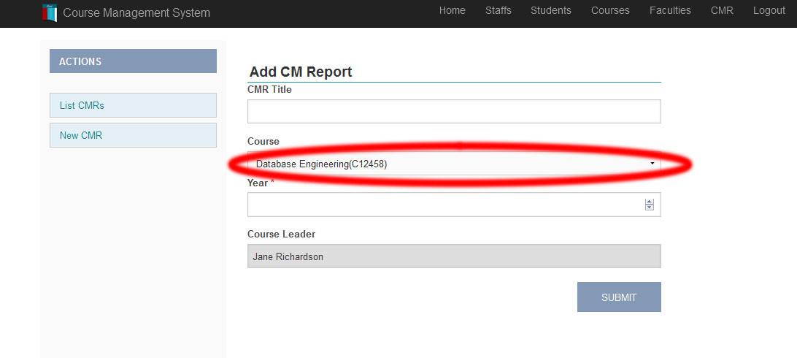

Figure 1 – Test 2.1 only allowed courses are visible

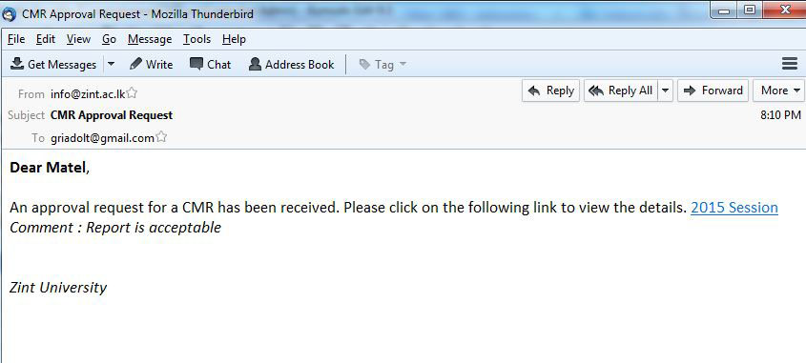

Figure 2 – Test 2.4 the email which is sent after CM approved a CMR

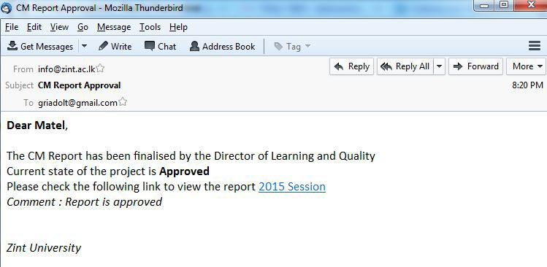

Figure 3 - Test 2.5 email sent after DLT approval or reject

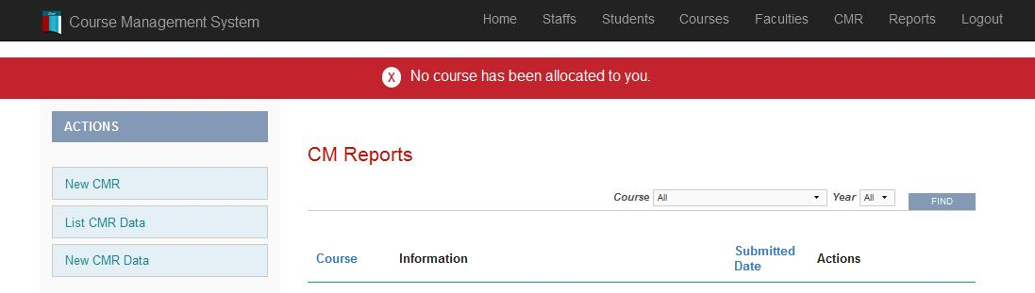

Figure 4 - Test 2.6 Error shown after trying to create a CMR